Developing your understanding 16.7

1 List four major religious beliefs or practices of ancient China.

2 What does dao mean?

3 Who was Laozi?

4 What is the literal meaning of wuwei? Can you think of a real-life example of how this idea might be applied?

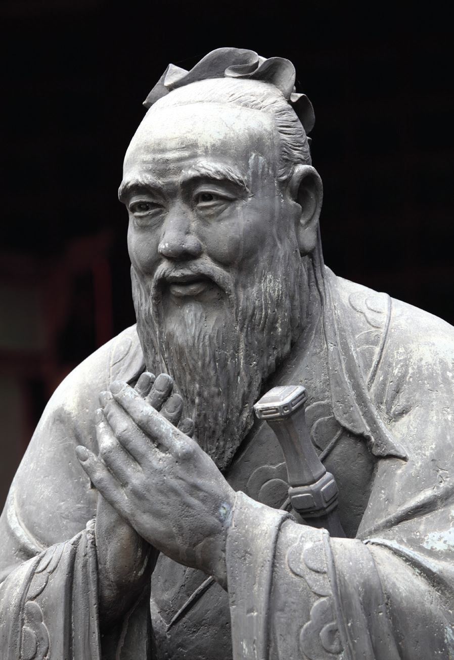
Source 16.15 Statue of Confucius at Confucian temple in
Shanghai, China

5 Source 16.15 represents the taijitu. Explain how this relates to Daoist beliefs.

